Appendix A
Maps Depicting Key Variables that Affect the Dynamics of the
Kanyabaha-Rushebeya Landscape.
Source: Collett, L. and A. Jarvis, 2008
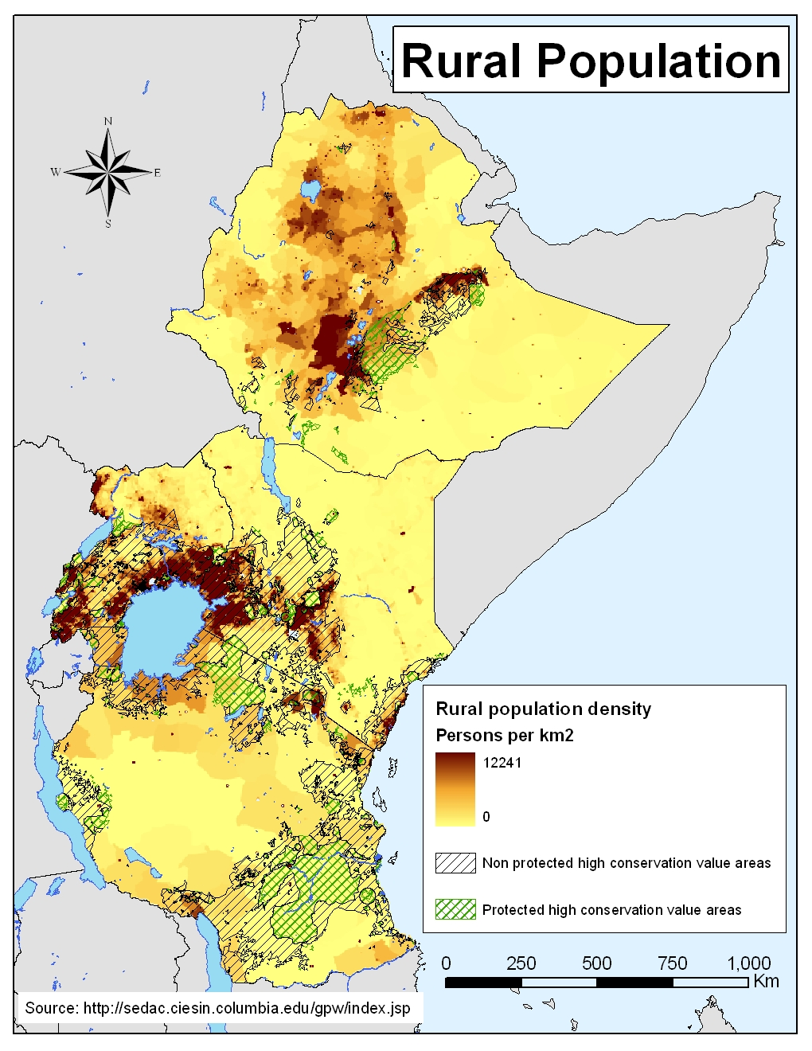

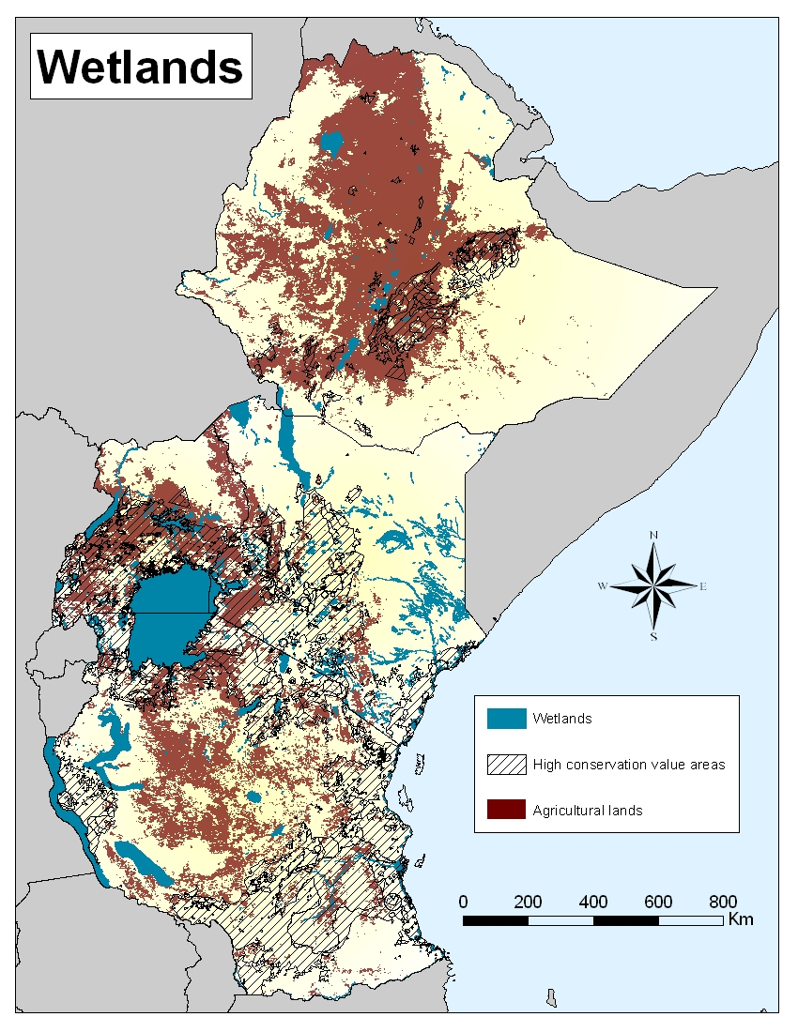

Percentage children with stunting in the study region (Source: )

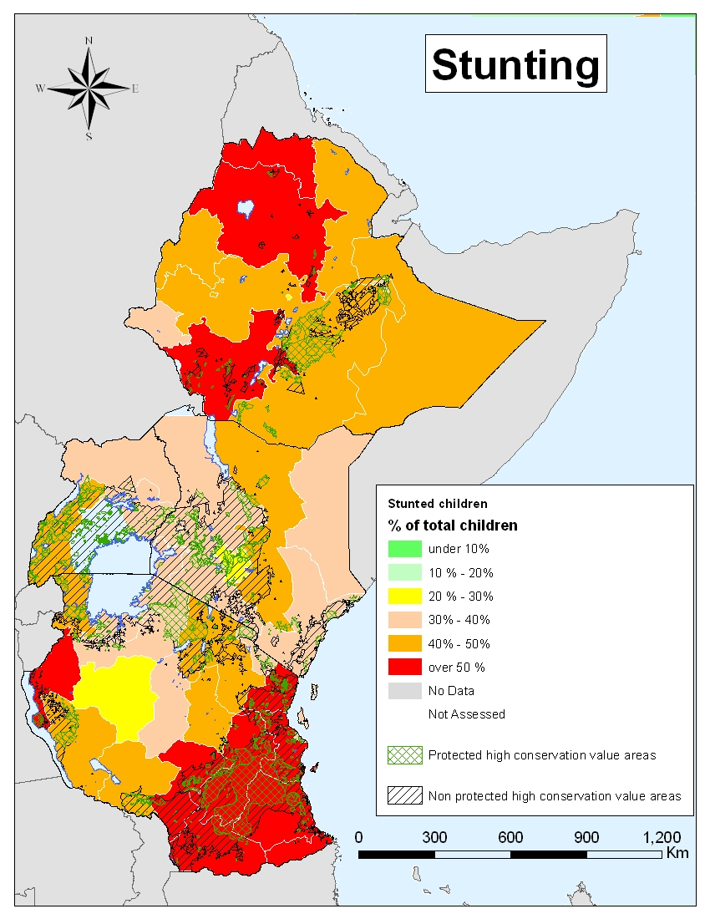
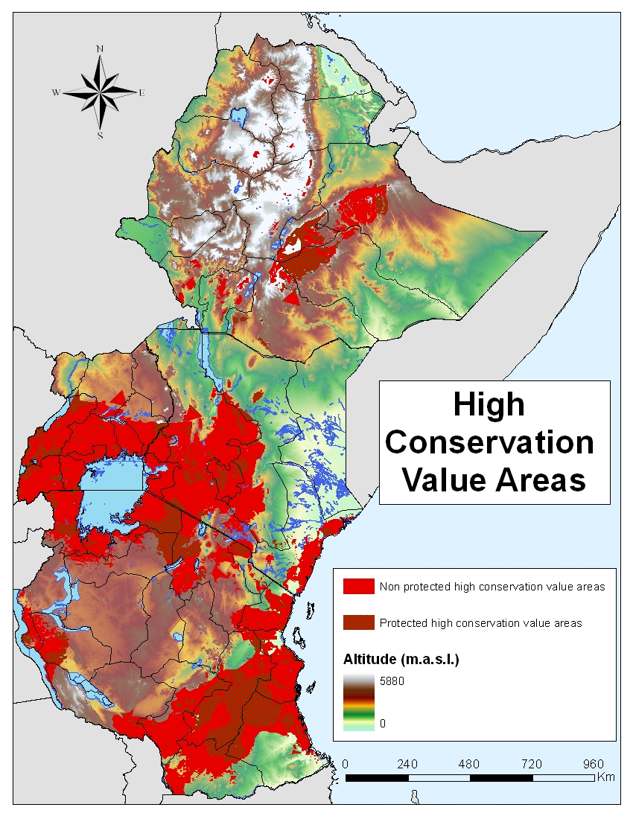

Map of high conservation value areas and protection status (Source: )

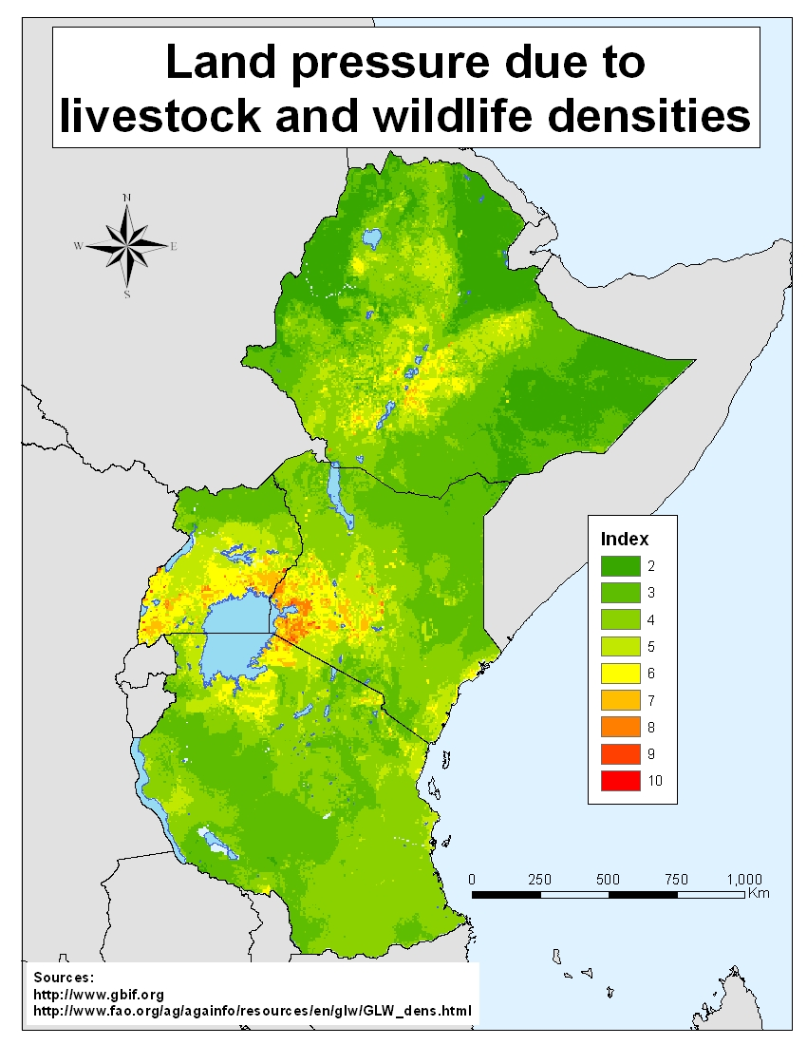

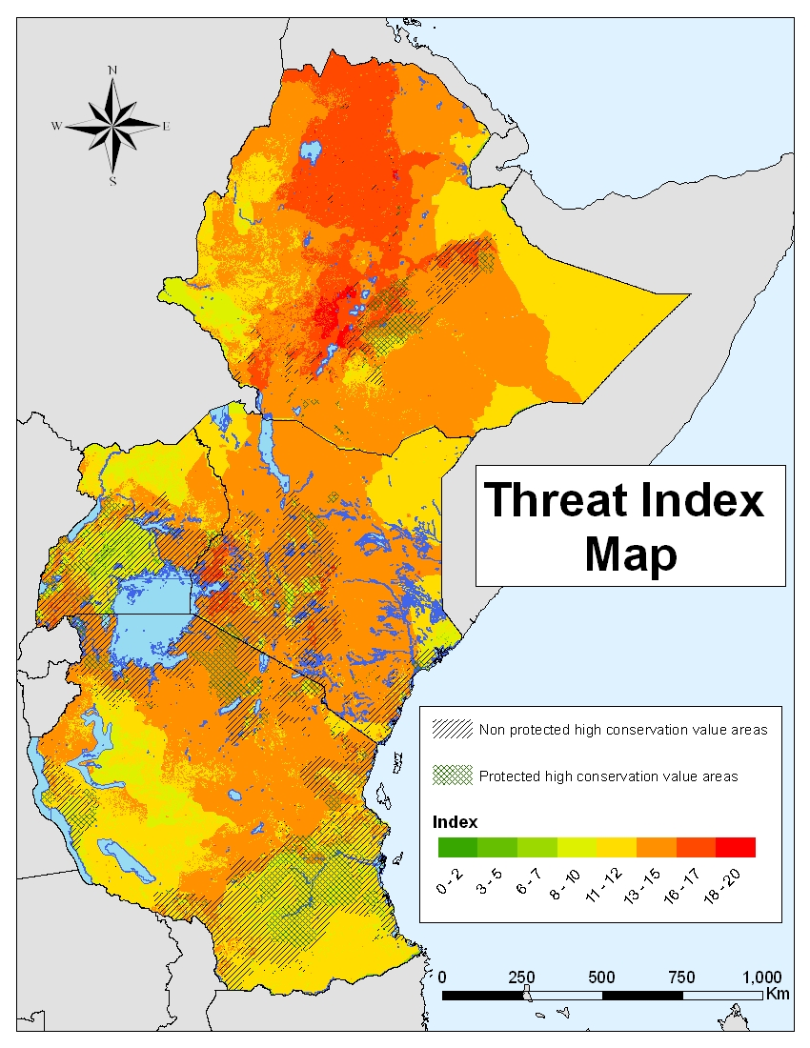
Index of pressure on land from resampled wildlife density and livestock density.

final index of hotspots for competing conservation and livelihood needs.

