Assessing the Performance of the Río Copán Watershed in Honduras:
The Landscape Measures Approach

The Río Copán watershed in western Honduras is not unlike many agricultural landscapes throughout the developing world. A journey through this 600 square kilometer watershed reveals a mixture of small and mid-sized farms producing cattle, coffee, and subsistence crops. Residents here face many challenges: recent population growth has led to deforestation and water pollution, while agricultural productivity is generally low and poverty levels remain high, especially among the indigenous Mayan population.

Environmental degradation is both a cause and a consequence of these problems. Poverty has driven many local people to cut wood in the vanishing native pine-oak forests or to cultivate or graze hillsides that are too steep for these purposes. Such practices, in turn, contribute to silted rivers unsuitable for human or livestock consumption and to landslides that routinely close roads and isolate villages from needed goods and services for weeks or months at a time. To meet the Millennium Development Goals (MDGs) in the Río Copán watershed will require not just new schools, new health centers, and new crop varieties; it will require a suite of coordinated activities, many of them focused on environmental restoration and natural resource management.

Fortunately, unlike many rural communities that address poverty issues piecemeal at the household or village level, Copán’s communities have recognized that these challenges grow from—and, in turn, influence—key dynamics and ecosystem processes operating at the scale of the entire watershed, and sometimes beyond. For local leaders, the wake-up call that spurred this landscape-level thinking arrived suddenly, drenching them, quite literally, like a bucket of cold water from above. In 1998, Hurricane Mitch tore through the region, wreaking havoc not just on de-vegetated hillsides but on the farms, villages, waterways, and infrastructure below.

After taking stock of the extensive damage, the four municipalities in the watershed decided to band together to form a regional coalition aimed at preventing such devastation in the future, and at finding solutions to shared problems such as erosion, water pollution, and poor human health. They created a vision and plan for the watershed’s future and, for the past several years, have been using this plan to target and guide externally-funded rural development activities. The problems and challenges in the watershed are not solved, but their root causes and interactions are now better understood. This knowledge encourages leaders to find solutions that do not trade off one landowner’s wellbeing for another’s, or one development objective for another, but that seek to maintain and restore the landscape’s natural and human capital for the benefit of all.

Jeffrey C. Milder, 2009

Río Copán, Honduras

The Río Copán watershed lies in extreme western Honduras, on the border with Guatemala. The 617 square mile landscape contains diverse topography and vegetation, with elevations ranging from 600-1600 meters. Native habitats include pine-oak forest, which is a globally threatened ecosystem, as well as dry and moist broadleaf forests.

Honduras currently has the highest poverty rate in Central America (70%) and ranks 115 out of 170 countries globally in the index of human development (Programa Estado de la Nación 2008). The Copán region is somewhat insulated from the worst poverty due to the significant tourism revenue associated with local Mayan ruins. Ironically, however, the most impoverished landscape residents remain the Chorti Maya, whose ancestors built these temples. As such, the landscape contains a diverse mix of stakeholders, ranging from wealthier landowners concentrated around the colonial town of Copán Ruinas—whose income is principally drawn from ecological and cultural tourism—to coffee and cattle farmers and the campesinos they hire to work their lands, to the Chorti Maya, who are largely segregated from the Mestizo majority and work as farm laborers or depend on subsistence agriculture.

The majority of families in the region rely heavily on natural resources for food and fuel. Land is cleared for agriculture, and the remaining forest fragments are heavily influenced by the extraction of fuelwood, and by the grazing of cattle, particularly during the dry season. Over-exploitation of the natural resource base has eroded the capacity of the landscape to provide critical hydrological services, and has exacerbated the fragmentation of the pine-oak woodlands that once dominated the landscape. The dominant land uses in the landscape are cattle ranching, milpas (small plots of corn, beans and squash), and coffee in the higher elevations.

The Copán watershed has been the focus of two important projects in which CATIE (Center for Tropical Agricultural Research and Higher Education) has been active. FOCUENCAS II has been working with local institutions for over four years to promote the participatory and collaborative management of the watershed with a particular focus paid to hydrological services, agricultural productivity, biodiversity conservation and institutional sustainability. The goals were identified by local institutions represented by a regional umbrella organization entitled the MANCOSARIC. CATIE also has been conducting a World Bank financed project entitled BNPP aimed at understanding and evaluating the impacts of silvopastoral systems on the conservation of biodiversity in the watershed.

The Landscape Measures Approach

One of the salient challenges of working at a landscape scale is to incorporate the important goals, processes, and dynamics into adaptive management without getting mired in excessive detail and layers of complexity (Lynam et al. 2007). To address this challenge, the Ecoagriculture Partners’ Landscape Measures Initiative (LMI) conducted a year-long consultative process that engaged scientists and practitioners from diverse disciplines and sectors in conversations about how to track change across multiple dimensions at landscape scale. An outcome of this process was a document entitled “Understanding Ecoagriculture: A Framework for Measuring Landscape Performance (Buck et al. 2006). This framework provides a practical and comparable method for measuring the performance of entire landscapes with respect to the goals of ecoagriculture. The stated purpose is not to determine whether a given landscape has attained a desirable end condition, but to assess whether it is moving in the right direction.

A central part of the landscape measures approach is a series of 20 questions that correspond with the four stated ecoagriculture goals: conserving a full complement of native biodiversity and ecosystem services, providing agricultural products and services on a sustainable basis, supporting viable livelihoods for local people, and establishing/maintaining institutions for integrating ongoing planning, negotiations, implementation and capacity building. The 20 questions represent the key variables that are likely to be important in ecoagriculture landscapes worldwide (Buck et al. 2006; Box 2-2).

The 20 Questions offer tangible criteria for assessing progress toward the four broad goals of ecoagriculture. In turn, stakeholders can answer the questions by selecting and evaluating context-appropriate indicators and means of measure (Buck et al., Table 2-2). Because many of the 20 Questions focus explicitly on the interactions among conservation, food production, rural livelihoods, and supporting institutions, they can help spur cross-sector dialogue and encourage stakeholders to negotiate tradeoffs among competing interests rather than avoiding such important conversations. Such effort is anticipated to lead to strengthened capacities for collaborative management of socio-ecological processes at landscape scale. Box 1 presents the 20 Questions.

Box 1. Twenty questions for assessing the performance of ecoagriculture landscapes. (Adapted from Buck et al. 2006.)
Conservation Goal: The landscape conserves, maintains, and restores wild biodiversity and ecosystem services.
Criterion C1: Does the landscape contain an adequate quantity and suitable configuration of natural and semi-natural habitat to protect native biodiversity?
Criterion C2: Do natural and semi-natural habitats in the landscape approximate the composition and structure of the habitats historically found in the landscape?
Criterion C3: Are important species within the landscape biologically viable?
Criterion C4: Does the landscape provide locally, regionally, and globally important ecosystem services?
Criterion C5: Are natural areas and aquatic resources degraded by productive areas and activities?
Production Goal: The landscape provides for the sustainable production of crops, livestock, fish, forests, and wild edible resources.
Criterion P1: Do production systems satisfy demand for agricultural products (crops, livestock, fish, wood) by consumers inside and outside the landscape?
Criterion P2: Are production systems financially viable and can they adapt to changes in input and output markets?
Criterion P3: Are production systems resilient to disturbances, both natural and human?
Criterion P4: Do production systems have a neutral or positive impact on wild biodiversity and ecosystem services in the landscape?
Criterion P5: Are species and varietal diversity of crops, livestock, fisheries and forests adequate and maintained?
Livelihoods Goal: The landscape sustains or enhances the livelihoods and wellbeing of all social groups who reside there.
Criterion L1: Are households and communities able to meet their basic needs while sustaining natural resources?
Criterion L2: Is the value of household and community income and assets increasing?
Criterion L3: Do households and communities have sustainable and equitable access to critical natural resource stocks and flows?
Criterion L4: Are local economies and livelihoods resilient to change in human and non-human population dynamics?
Criterion L5: Are households and communities resilient to external shocks such as flooding, drought, changes in commodity prices, and disease epidemics?
Institutions Goal: The landscape hosts institutions that support the planning, negotiation, implementation, resource mobilization, and capacity-building needed to integrate conservation, production and livelihood functions.
Criterion I1: Are mechanisms in place and functioning for cross-sectoral interaction at landscape scale?
Criterion I2: Do producers and other community members have adequate capacity to learn and innovate about practices that will lead to integrated landscapes?
Criterion I3: Does public policy support integrated landscapes?
Criterion I4: Are market incentives conducive to integrated landscapes?
Criterion I5: Do knowledge, norms, and values support integrated landscapes?

Applying the Landscape Measures Framework in Copán

A faculty member and Master’s degree student at CATIE collaborated with a PhD candidate at Cornell University who co-designed the Landscape Measures (LM) framework, to
evaluate the capacity of the framework to support multi-objective, cross-discinplinary assessments, and integrated self-analysis by multi-stakeholder management entities at the landscape scale. The application of the LM approach in Copán illustrates how it can be used to conduct a broad-reaching baseline evaluation of landscape conditions and to elucidate and prioritize community needs.

As highlighted earlier, there is already some institutional capacity in the Río Copán watershed for carrying out landscape approaches to natural resource management and community development. A regional governing body known as the MANCOSARIC represents the watershed’s four municipalities and works to improve basic human services while facilitating adaptive co-management with an emphasis on improving flows of ecosystem services and reducing risks from natural hazards such as flooding and landslides. The MANCOSARIC also helps empower local governments to take responsibility for natural resource stewardship through integrated watershed management.

The MANCOSARIC and its partners assumed responsibility for implementing the LM and the 20 Questions to provide a baseline evaluation of the watershed that would help them understand the current status of the landscape, identify priorities, and refine current landscape management plans. The landscape was particularly suitable for such evaluation because of the existence of the MANCOSARIC governing body, which was well positioned to utilize the information generated. The evaluation also promised to offer a wider perspective on the region and a starting point for initiating critical discussion on stakeholder priorities.

The baseline evaluation conducted by Bejarano (2009) was designed to synthesize useful information from pre-existing studies while generating strategic new data to answer some of the 20 Questions deemed most critical by local stakeholders. Many of the landscape performance measures included in the assessment were derived or extrapolated from land use patterns and dynamics. In this regard, the MANCOSARIC was fortunate to have a 1-meter resolution IKONOS satellite image of the landscape acquired in 2007 that was classified into land uses at the plot scale (Sanfiorenzo 2008). This land use map provided a foundation for much of the landscape evaluation, allowing stakeholders to analyze information on production, conservation and livelihood indicators in a spatially explicit manner to understand where interventions and improvements were most needed.

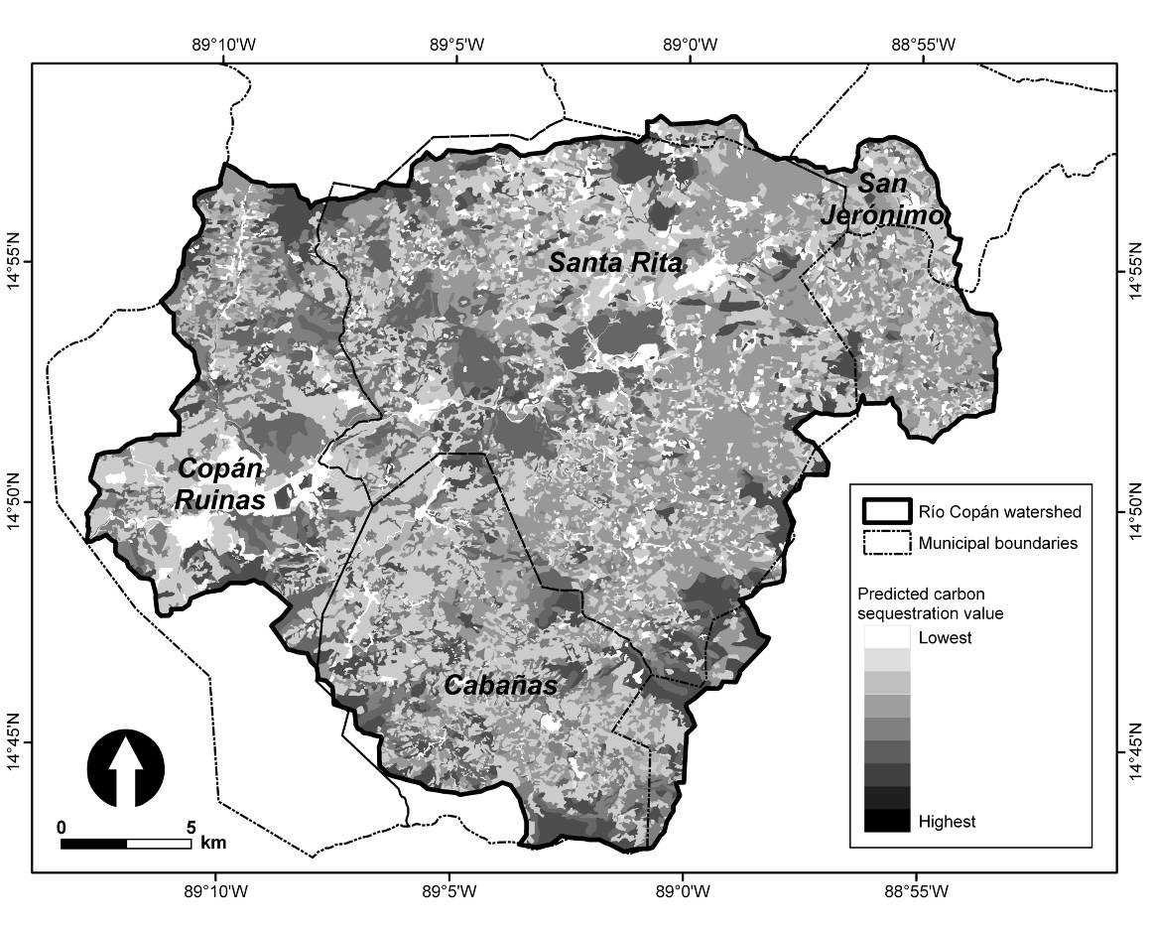
Figure 1. Predicted distribution of carbon sequestration services provided in the Copán landscape based on estimates of the capacity of each land use to store carbon (Murgueitio et al. 2004).

One application, for example, was the interpretation of land use patterns to estimate the provision of ecosystem services throughout the watershed (Figures 1 and 2). While land use is not a precise proxy for such services, prior study has yielded enough information on the relationships between land use, biodiversity conservation, and carbon storage to help identify hotspots where ecosystem services have been eroded and where restoration efforts could address both conservation and livelihood goals. The spatially explicit nature of these maps facilitates negotiation by identifying specific property owners and municipalities that could benefit from interventions.

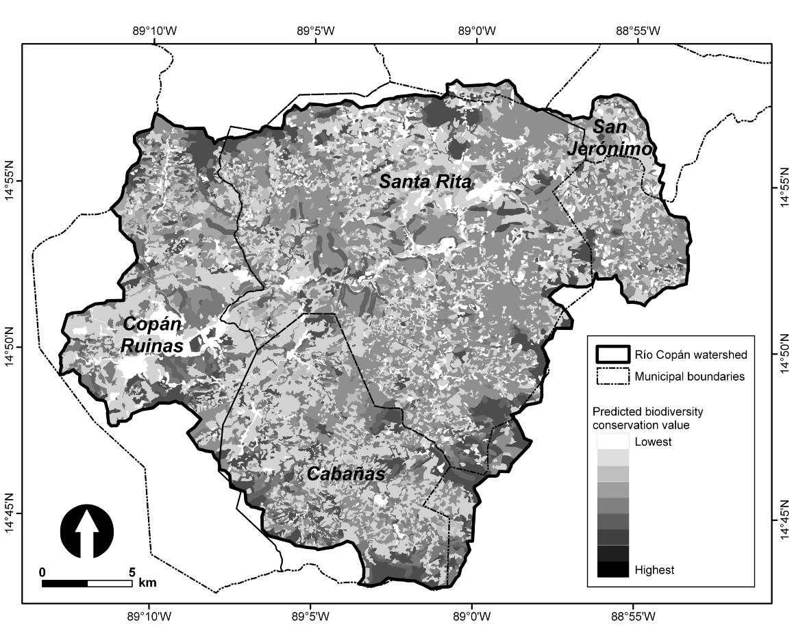
Figure 2. Predicted biodiversity conservation value of the Copán landscape based on estimates of the capacity of each land use to sustain native species (Murgueitio et al. 2004).

While landscape composition and structure metrics were an important part of the landscape evaluation, it was critical to supplement these measures with household interviews and plot-level field studies to answer many of the 20 Questions. For example, one of the surrogate measures for conservation criteria 1 and 3 (see Box 1) was to ask farmers when they had last seen a wild deer. Representative patches of each forest type in each community were also surveyed to evaluate vegetation structure and evidence of degradation from grazing, timber or fuelwood extraction, and other human interventions. This study indicated that forests are more degraded in Cabañas—where the economy is heavily based on natural resources—than in Copán Ruinas, a larger town with a more diversified economy.

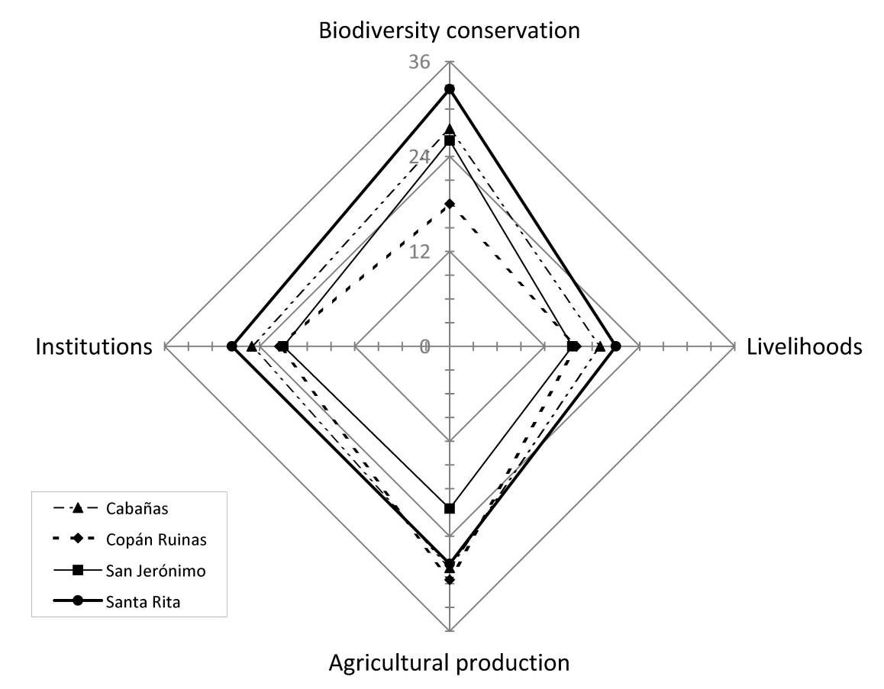
Figure 3. Spider diagram indicating current performance of each of the four municipalities in the Río Copán watershed with respect to each of the four axes of ecoagriculture: food production, conservation, livelihoods and institutional support. Scores for each axis are reported in dimensionless units based on a summation of scores for the five criteria under each ecoagriculture goal. These data are derived from mixed methods including household interviews, ecological field sampling, and land use analyses, as described in the text. The diagram provides a simplified performance metric to help assess existing conditions, set priorities, and establish a baseline against which to measure future progress. This figure is re-drawn from Bejarano 2009.

The evaluation of livelihood indictors was primarily based on household interviews (45 per municipality). These were spatially stratified and located with GPS coordinates to allow spatially explicit analysis of the relationships among multiple goals. Interviews revealed household members’ education levels, production activities, agricultural yields, farm income, total income, and other factors. Results were integrated with those from earlier household surveys focusing on farm-level conservation practices and access to water and energy resources. Both sets of interviews also assessed the degree to which local social service and resource management entities were providing households with services, training, or sharing of ideas—and
the degree to which farmers were aware of relevant projects. These data helped define the effectiveness and sphere of influence of local institutions relative to their mission and objectives. The data also revealed spatial patterns of wealth and poverty—including both current income and capacity to improve and adapt household livelihood strategies. Again, the evaluation documented greater levels of poverty and need in the more resource-dependent communities outside of the tourism nexus (and MANCOSARIC headquarters) in Copán Ruinas.

The landscape evaluation reported answers to each of the 20 Questions individually, and also combined outcomes into the four basic ‘axes’ of ecoagriculture to help frame stakeholder discussion about landscape priorities (Figure 3). This type of synthesis is rife with challenges and value judgments. (How do you weigh each indicator? Can landscape outcomes be traded off against each other, or must some or all objectives be met at a basic level?) But rather than forming an insurmountable barrier, such value questions can provide a starting point for dialogue about synergies and tradeoffs among disparate objectives.

In addition to providing a baseline assessment of landscape performance, the evaluation also explored various policy alternatives for improving outcomes to several of the 20 Questions. Framing policy analysis in terms of the 20 Questions is an alternative to sectoral analyses that predict the direct results of interventions while ignoring their indirect or feedback effects.

For example, Sanfiorenzo (2008) conducted landscape modeling to evaluate the effects on biodiversity of proposed policies for reducing erosion, landslides, and water pollution in the landscape, which hinder progress toward several of the MDGs. A baseline analysis evaluated forest patch size, fragmentation, and functional connectivity of the existing landscape from the perspective of the genus trogon—forest-dependent birds that are also highly sought after by ecotourists. Forest cover comprised 25% of the 598 square kilometer landscape, but this habitat was fragmented into 145 isolated patches. Sanfiorenzo (2008) then evaluated the effects of three potential policies: 1) enforcing the Honduran law to protect 10 m forested buffers alongside all rivers and streams, 2) converting steep slopes (14-40%) to agroforestry systems such as shaded coffee or pasture with high tree density, and 3) revegetating all very steep slopes (>40%) to natural forest or timber plantations. The models revealed that riparian buffers would decrease the number of isolated forest fragments from 145 to less than 40, while the three policies in combination would increase suitable trogon habitat from 22% to 38% of the landscape. The analysis not only sheds light on several of the 20 Questions (e.g., C1, C4, P4, L3, and L5; see Box 1); it also identifies the most promising target areas for restoration.

Conclusions

Reflecting on the LM evaluation in Copán, the approach at first glance seems similar to standard assessment methods, such as Rapid Rural Appraisal, that combine interviews and other forms of baseline data collection to identify needs and priorities. However, on closer examination, several key differences emerge. One is the use of an integrative framework to steer communities and field technicians to consider the possible importance or feedback effects of issues that have been neglected locally. Second is an emphasis on land use and landscape patterns as durable—though manageable—underlying drivers of many of the socioeconomic themes that are often the focus of rural appraisals. Third is a focus on quantitative indicators that can be cost-effectively measured on a regular basis to track the direct and indirect effects of landscape interventions, as well as the feedbacks between these interventions and exogenous policy and market forces.

Based on the cost of the initial assessment, repeating LM evaluations every 2-3 years as part of a landscape planning and adaptive management program would cost approximately $50,000 to $70,000. The MANCOSARIC has learned that such up-front investment can pay for itself many times over in helping to attract and target foreign assistance to communities that have a clear vision for the future and understand which projects and interventions will help them achieve this vision.

Question

What key indicators of the performance of the agrosilvopasture landscape in Copan might you recommend MANCOSARIC (territorial management group) track over time? What methods might they use to measure the indicators that would involve professional natural resource managers together with local community members in learning about their landscape and better ways of managing it?

References

Bejarano, L.F. 2009. Evaluación metodológica del enfoque de Ecoagricultura para medir el desempeño de un paisaje con matriz agropecuaria en la subcuenca del Río Copán, Honduras. Master’s thesis. Centro Agronómico Tropical de Investigación y Enseñanza, Turrialba, Costa Rica.

Buck, L.E., J.C. Milder, T.A. Gavin, and I. Mukherjee. 2006. Understanding ecoagriculture: a framework for measuring landscape performance. Ecoagriculture Discussion Paper #2. Ecoagriculture Partners, Washington, D.C.
Lynam, T., W. de Jong, D. Sheil, T. Kusumanto, and K. Evans. 2007. A review of tools for incorporating community knowledge, preferences, and values into decision making in natural resources management. Conservation Ecology 12(1): Article 5.
.
Milder, J.C. 2010. Ecoagriculture and Biodiversity Conservation: Concepts, approaches and evidence from Northern Latin America. A Dissertation Presented to the Faculty of the Graduate School of Cornell University in Partial Fulfillment of the Requirements for the Degree of
Doctor of Philosophy, Cornell University, Ithaca, NY.

Sanfiorenzo 2008. Sanfiorenzo, A.R. 2008. Contribución de diferentes arreglos silvopastoriles a la conservación de la biodiversidad, mediante la provisión de hábitat y conectividad en el paisaje de la sub-cuenca del Río Copán, Honduras. Master’s thesis. Centro Agronómico Tropical de Investigación y Enseñanza, Turrialba, Costa Rica.

Biosketches of Key Contributors to Case Study

Luis Bejarano is a Honduran native who received his Master’s degree at CATIE in Costa Rica in 2009. He is experienced in working with cattle farmers and in agricultural development through Peace Corps Honduras. He has worked with formal and informal groups of coffee farmers, horticultural producers and cattle growers on planning, monitoring, executing and managing sustainable projects. He holds an agronomist engineering degree from the Escuela Nacional de Agricultura (ENA) in Honduras and worked for three years with the United Nations (UNDP) as a consultant for food safety in eastern Honduras (2001-2004), managing over 60 farmer groups and training them in Musaceas plantations and the management of rural irrigation systems.

Fabrice DeClerck PhD is a professor of landscape ecology at CATIE, and also is an Adjunct Research Associate with the Tropical Agricultural Program at Columbia University. Fabrice’s work focuses on the relationship between biodiversity and ecosystem functioning, particularly in managed landscapes. His current work attempts to scale his work in functional diversity and ecosystem functioning up to the watershed level.

Jeff Milder received his PhD degree in the Department of Natural Resources at Cornell University (Ithaca, New York) in 2009, and presently is Director of Strategic Planning and Research at Ecoagriculture Partners (Washington, DC). His PhD research examined relationships between wild biodiversity and landscape structure at multiple scales in silvopastoral systems in Central America. He holds a MSc in Natural Resources from Cornell University and a BA in Earth Sciences from Harvard University.

Louise Buck draws heavily upon Dr. Jeff Milder’s PhD dissertation research (2009) in preparing this case study, particularly Chapter 2. Jeff collaborated in this research with Dr. Fabrice DeClerck, faculty member at CATIE in Costa Rica, and with Mr. Luis Bejarano who earned his Master’s degree at CATIE. Short bio-sketches of these researchers follow the Reference section in the case.
FOCUENCAS II is the project entitled “Innovation, knowledge and communication for adaptive watershed co-management,” financed by ASDI (Switzerland-International Cooperation Agency).
The MANCORSARIC is an association of four adjacent municipalities within the Rio Copan watershed: Copan Ruinas, Santa Rita, Cabañas and San Jerónimo.
³ Bank Netherlands Partnership Program.

